
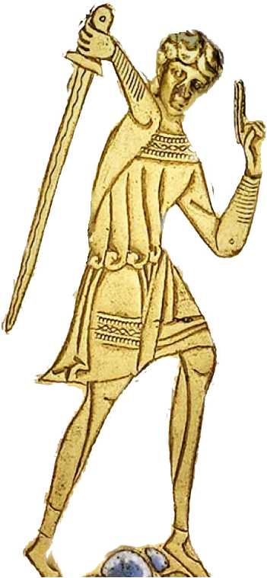
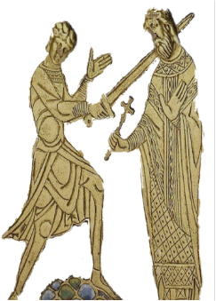
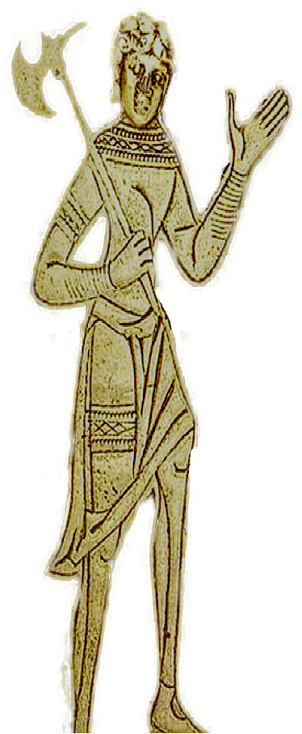
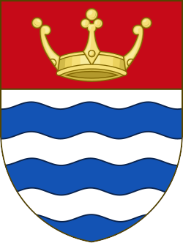
Greater London Province of
St Thomas of Acon

Provincial Newsletter First Edition 2025-26

Foreword by the Right Worthy Grand Preceptor

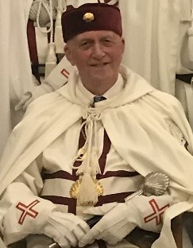
Welcome to the first edition of the Provincial newsletter which, I hope, will enable knights to keep abreast of all that is happening in the Province. When presenting my annual report at the annual meeting, I announced that Sir Anthony of Royal Eltham (Tony Maslin) had accepted my invitation to undertake the role of webmaster for a potential Provincial website. This will be a conduit in disseminating information, not only from me and members of the Provincial Executive, but from each of the Chapels in the Province, and the Order as a whole.

Sir Knights, this newsletter is a ‘toe in the water’ to gauge whether such a medium will provide members with an additional outlet to communicate news and issues of relevance from each of our Chapels.
The success of this venture can only be measured by the interest and participation adopted by you and I look forward to the successful launch of the website, with future newsletters. It is anticipated that a regular newsletter (initially, twice per year) will be produced. However, such an undertaking cannot be the product of a few individuals, but the involvement of members of the Order from each Chapel who are prepared to be involved in submitting articles of their respective meetings, with photographs and anecdotes of interest. Once the website is launched it will provide controlled access to those masons who are qualified to be a member of the Order and who might be encouraged to participate in a pilgrimage that will end in their membership of this Order of Chivalry.

The newsletter will be produced and published under the watchful eye of its

first‘ Editor-in-Chief’, Sir Robert of Falkirk (Bob Chevin).

Sir Peter of Eltham

1 Publisher by A.J Maslin
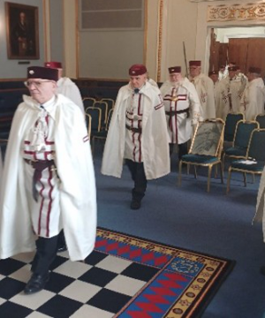
Annual Provincial Meeting 26th April 2025

The annual meeting of the Grand Preceptor’s Council was held at Mark Masons’ Hall on Saturday 26 April at which the Greater London Province was honoured by the presence of the Most Worthy Grand Master, Sir Philip of Hamilton KH,
In addition, there were present the Right Worthy Grand Preceptor’s of Central Midlands, East Anglia, East Midlands, Essex, Hampshire & I.O.W. Wessex, West Country, the Provincial Prior of South-East Counties, and the Deputy Assistant Grand Secretary of Lancashire, many of whom were accompanied by members of their respective Provinces.

Two District Grand Prefects of the Order of the Allied Masonic Degrees, RW Bros Robert Chevin and Jeffery Conway were, likewise, welcomed. With 20 other members, representing each of the Chapels of the Province, the Provincial meeting was well attended this year

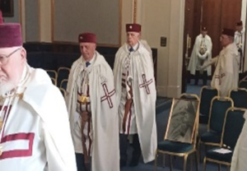
The Right Worthy Grand Preceptor, Sir Peter of Eltham, was escorted into the Council, accompanied by his Officers of the year. On welcoming all present, Provincial Grand Council was opened in due form. Under the direction of the Provincial Grand Marshal, The Right Worthy Grand Preceptor was saluted accordingly.

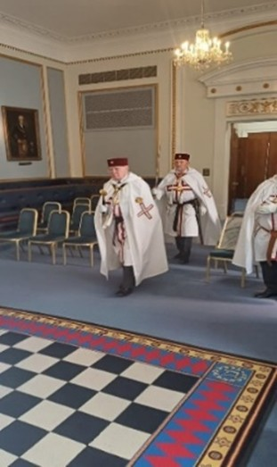
There followed a report, and the Grand Marshal was admitted into Grand Temple to announce the presence of the Most Worthy Grand Master, demanding admission into the Council.

The Most Worthy Grand Master entered Grand Temple accompanied by the Most Excellent Grand Prior, Sir Harry of Benfro KH, the Grand Secretary, Sir Derek of Anfield, KH, and other Grand Officers under the direction of the Grand Marshal, Sir Steven of Wirksworth KC.

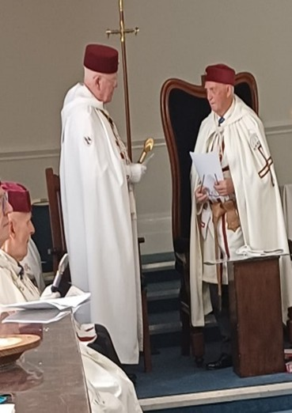
The Right Worthy Provincial Grand Preceptor warmly welcomed the Most Worthy Grand Master, who was duly saluted, under the direction of the Grand Marshal. The Most Worthy Grand Master responded informing the assembly of his delight at being able to attend the Provincial meeting.
Following a requiem to departed merit and the roll call of members present, the Right Worthy Grand Preceptor was pleased to re-appoint Sir David of Narberth as his Provincial Grand Prior.

2 Publisher by A.J Maslin
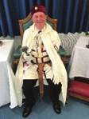
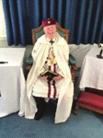
Annual Provincial Meeting 26th April 2025

There followed the appointments, re-appointments, and investitures of Provincial Grand

Officers as follows:

Marshal

Treasurer

Registrar

Secretary

Dep. Marshal

Almoner

Warden of Regalia

Sword Bearer

Dep. Secretary

Banner Bearer

Asst. Marshal

Herald

Organist

Doorkeeper

Cellarer

Cellarer

Cellarer

Cellarer

Cellarer

Cellarer

Sir Alan of Old Coulsdon (Brockwell)

Sir David of Chiswick (Burton)

Sir Robert of Hammersmythe (Chilvers)

Sir Douglas of Duston (Black)

Sir David of Aberdare (Richards)

Sir Royston of Fleet Hargate (Glencross)

Sir Robert of Odiham (McMillan)

Sir John of Barnet Vale (Roberts)

Sir Thomas of Mowbray (D’Souza)

Sir Robert of Falkirk (Chevin)

Sir Paul of Kilmainham (Fitzgerald)

Sir Leslie of Windsor (Grout)

Sir Matthew of Wimborne (Burt)

Sir Ian of Seavington (Pamplin)

Sir Savvas of Amadeus (Savva)

Sir Hugh of Merstham (Everitt)

Sir John of York

Sir René of Hilversum

Sir Graham of Worcester Park

Sir Ronald of Siddington

Pride of Surrey

Coeur de Lion 8

Blackheethe TI

St James 86

Coeur de Lion 8

Coeur de Lion 8

Blackheethe TI

Clarendon 75

Coeur de Lion 8

St James 86

Blackheethe TI

Pride of Surrey

Blackheethe TI

Blackheethe TI

Coeur de Lion 8

Pride of Surrey

Coeur de Lion 8

Coeur de Lion 8

Pride of Surrey

St James 86

The Provincial Grand Secretary announced that the Province had achieved a net total in membership of 12, with 11 new members and 5 joining members, against 1 death, 2 resignations, and 1 exclusion. This outcome could only bode well for the Province in anticipation of an increase of further members.

On the completion of all administrative matters, the Most Worthy Grand Master retired from the Provincial meeting, attended by the Grand Officers who had accompanied him on his entry into the Council. The Provincial meeting was closed in due form, followed by the singing of the National Anthem and closing hymn, the Right Worthy Grand Preceptor, accompanied by his Provincial Officers, processed from the Council under the direction of the Provincial Grand Marshal.

With the matter of re-hydration fulfilled at the bar, 40 diners attended the Festive Board for a most pleasing carvery (and short speeches). All departed with cheer and an invitation to attend the next Provincial meeting in 2026.

3 Publisher by A.J Maslin
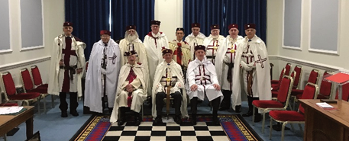
Chapels Meetings

St James’s Chapel No 86 - 29 Jun 25

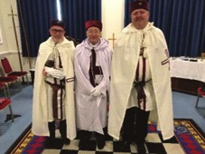
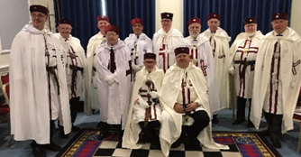
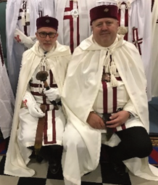
Knight Joseph Chapman underwent the reception of a candidate and was Admitted into the Order. On completing each of the challenges and undertaking the oaths required of him, he was duly knighted, Sir Joe of Plasnewydd, in the customary manner of the Order. The new knight, having received copies of the Constitutions and By-Laws was duly saluted by the knights and invited to take his seat in the chapel.

There followed the installation of Sir William (Winter) of Holzweiler as Worthy Master for the ensuing year and was duly saluted as the Worthy Master.

The Worthy Master appointed and invested his Officers and at the conclusion of all administrative matters, the Chapel was closed in harmony until the next regular meeting

St James’s Chapel No 86 - 29 Sep 25

This meeting was honoured by the presence of the Provincial Grand Preceptor, Sir Peter of Eltham. With the absence of the Worthy Master on this occasion, the Provincial Grand Preceptor readily accepted the invitation to act as the Worthy Master. With a meeting of the London Provincial Priory in the afternoon, the Chapel benefitted with an increase in the numbers attending the Chapel.

The Prior had been absent at the installation meeting and was invested by the acting Worthy Master. There followed the presentation of 2 Grand Master’s Council certificates by the Provincial Grand Preceptor, who gave an interesting insight into the history of the scallop shell, adopted in the Order, and used as a visible sign by pilgrims, as well as the importance of St James – a disciple of Christ – associated to the Order.

The presentation of a paper, researched by the Marshal, (Sir Robert of Falkirk) on the ‘Life of St Thomas a’ Becket’, was well received, and with the 2 presentations in succession, all knights managed to remain awake throughout – a testimony to their resolve!

4 Publisher by A.J Maslin
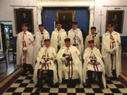
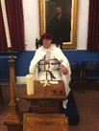
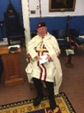
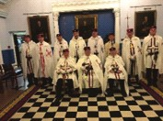
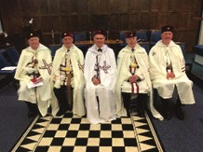
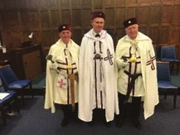
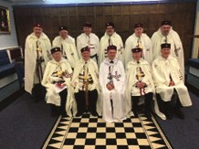
Chapels Meetings

Pride of Surrey Chapel - 13 Oct 25

The meeting was honoured by the presence of the R W Grand Preceptor and Provincial Grand Prior, which by the time the meeting closed, both had been admitted as Joining members of the Chapel – visiting can engender surprises! The admission of both the Provincial Grand Rulers increased the membership numbers, which had become a cause for concern. The meeting, though, allowed for another increase to the membership of the Chapel with the admission of Kt Stephen Bignell, who undertook the challenges and obligations required to become a knight of the Order, and being suitably invested, took his place in the Chapel. Following the business of the Chapel, the knights retired to the bar for a fish and chip supper, which capped a most enjoyable and happy meeting.

Clarendon Chapel - 17 Nov 25
Over recent times the Chapel has experienced a reduction in the overall membership and seemed to be destined to fold. However, there had been a sudden upsurge coinciding with the Provincial Grand Preceptor becoming a Joining member along with an additional 4 members of the Order. The increase in the membership helped fill several of the vacant offices, in particular that of secretary, which the Provincial Grand Preceptor agreed to undertake until such time as the Worthy Master completes his second year in office when he will relieve the Grand Preceptor of his duties as secretary.

5 Publisher by A.J Maslin
Chapels Meetings

Blackheethe T.I. Chapel - 20 Dec 25

This was a most delightful and resounding meeting with two Joining members, one Re-joining member, and a candidate to add to the growing membership of this Time-Immemorial Chapel. With the presence of the Provincial Grand Preceptor, and Provincial Prior, in his role of secretary, the meeting was led by the marshal, Sir Jeffrey (Conway) of Legra, in the absence of the Worthy Master.

With the absence of other officers, several visitors kindly accepted an invitation to take the vacant offices, all performing to a high standard of ritual ensuring the candidate received a high-quality ceremony. The candidate, now registered as Sir Phillip (Purves) of Oxenforde, was saluted by the knights present and welcomed by Sir Peter of Eltham (Provincial Grand Preceptor).

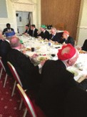
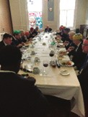
At the conclusion of the meeting, and thirsts quenched, the Chapel dined together in harmony and departed with much Christmas cheer until the next meeting on Saturday 20 June 2026.

6 Publisher by A.J Maslin
Grand Master’s Council Meeting – 29 December 2025

Thomas Beckett, Archbishop of Canterbury, was murdered by 4 mercenary knights. Unless the date coincides with a Sunday, the Grand Master’s Council is always held on 29 December, albeit the day of the meeting will change. So it was that on a Monday this year the Grand Master opened the Council in the Derby Masonic Hall where the temple was filled to capacity.

Sadly, one of our knights was taken ill and was eventually taken to hospital by ambulance. Because of the time lost in recovering the knight, the Grand Master fulfilled the Constitutional obligation with a truncated assembly. Knights attending for Grand Rank preferment were invested en-bloc,whilst those receiving a first appointment stood in line along whilst the Grand Master approached each knight and invested him, accordingly. This change to the customary manner of the meeting did not in any way detract from the significance and importance of the occasion which, with the time made up, ensured all dined at the allocated time. During the festive board the Grand Master invited all to remember absent knights, and in particular, our missing knight now recovering in the Derby General Hospital. We wish him well for a speedy recovery.

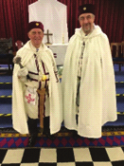
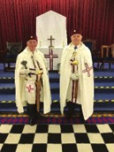
The Province was well represented with several members in attendance, including the Grand Preceptor and Grand Prior. Two knights were in attendance to receive first appointments in Grand Rank – Sir David of Aberdare (Richards) appointed to Past Assistant Grand Marshal and Sir Robert of Falkirk (Chevin), as Past Grand Herald.

Prov Grand Preceptor and
Sir David of Aberdare
Prov Grand Preceptor and
Sir Robert of Falkirk

Editor: Bob Chevin ranchmuir03@gmail.com

7 Publisher by A.J Maslin

